1. Architectural Design & Justification
1.1 Architectural Overview
In this section, define the organizing principle of your Lost and Found system.
- System Scale: The project follows Architecture in the Small, focusing on the decomposition of a single program into components.
- Primary Strategy: To manage uncertainty regarding future requirements and technology choices, we have adopted a high-level infrastructure that prioritizes modularity and separation of concerns.
- Selected Patterns: The system integrates Layered Architecture and the Model-View-Controller (MVC) pattern.

1.2 Pattern 1: Layered Architecture
Explain the horizontal organization of your system.
- Definition: This style organizes the system into a set of layers, where each layer provides services to the one immediately above it.
- Suitability: This is highly suitable for an information system like ours because it models the interfacing of sub-systems (UI, Logic, and Data).
- Support for Requirements:
  - Data Isolation: By keeping the database in an inner layer, we protect critical assets.
  - Incremental Development: Since our team has five members, this pattern allows us to develop sub-systems in different layers simultaneously.
- Code Reference: The Repository classes represent the Data Access Layer, while the Service classes act as the Business Logic Layer.

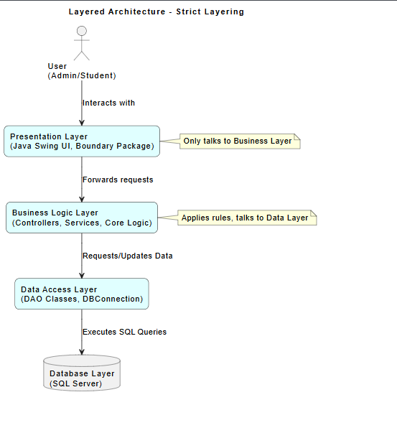

1.3 Pattern 2: Model-View-Controller (MVC)
Explain how you separate the UI logic from the data handling.
- Definition: MVC separates the system into three logical components: the Model (data management), the View (data presentation), and the Controller (interaction logic).
- Suitability: This is used because the "Lost and Found" system requires multiple ways to interact with data (e.g., student search vs. admin management).
- Support for Requirements:
  - Independent Change: It allows the user interface (View) to be updated or replaced (e.g., changing from a desktop app to a web browser) without modifying the core logic.
  - Control Flow: The Controller manages key presses and mouse clicks, passing these to the Model to update item states.
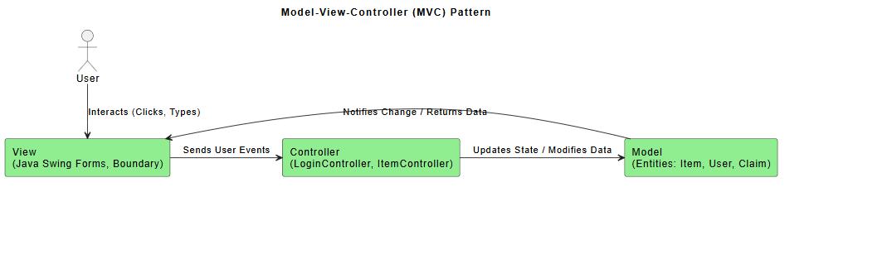

1.4 Complementary Relationship
- Macro vs. Micro: Layered Architecture provides the global structure, while MVC is implemented within those layers.
- Mapping:
  - The MVC View lives in the Presentation Layer.
  - The MVC Controller lives in the Business Layer.
  - The MVC Model interacts with the Data Access Layer.
- Benefit: This combination ensures the system is logically organized to support non-functional requirements like security while remaining flexible enough to support multiple UI views.

2. Non-Functional Requirements (NFRs) Mapping
Identify how your architectural decisions satisfy the quality attributes required by the doctor.

Non-Functional Requirement How Architecture Supports It
Security:
We utilize Layered Architecture to keep the core assets (the system database) in the innermost layer, isolated from direct user contact by the Business and Presentation layers.
Maintainability:
By using fine-grained, replaceable components in the MVC pattern, individual features or UI elements can be updated without necessitating a system-wide overhaul.
Performance:
Critical operations are localized within the Business Layer to minimize communication overhead between distant components, which is a key strategy for maintaining speed.
Scalability:
The MVC pattern allows the system to scale by adding new views or interfaces (e.g., a web-based dashboard) while reusing the same underlying Model and Business Logic.
Availability:
The decoupled nature of the layers enables the future inclusion of redundant components or fault-tolerance mechanisms specifically within the data tier without affecting the UI.
3. Conceptual View (Block Diagram)
The Conceptual View identifies the main structural components of the Lost and Found system and the high-level relationships between them. This view utilizes an informal "box-and-line" notation to facilitate clear communication regarding the system's global organization and separation of concerns.
As shown in the diagram below, the system is decomposed into distinct functional subsystems:
- User Interface: Implemented via Java Swing screens to handle interaction for all user roles.
- Application Logic: The core engine managing authentication and business rules.
- Notification Subsystem: A specialized module for handling system alerts and messages.
- Data Management & SQL Database: The persistence layer responsible for secure data operations.
This view establishes the high-level communication architecture, showing how requests flow from the presentation layer through the application logic to the database engine.
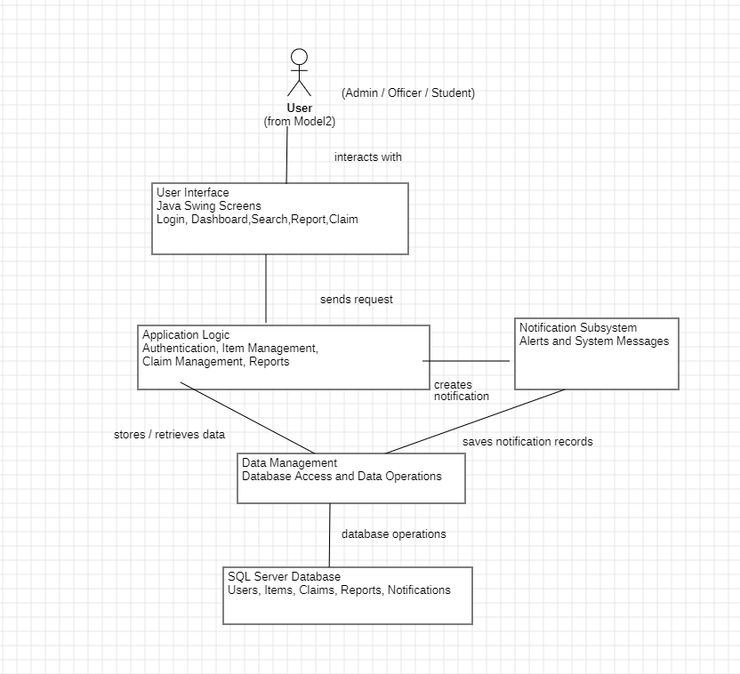

4. Process View (Dynamic Behavior)
The Process View captures the runtime behavior and interaction between system objects. This view utilizes two specific models to describe the Item Claim Process, ensuring that all functional requirements are mapped to specific architectural actions.
Model A: Activity Diagram
- Description: This model uses swimlanes to illustrate the workflow across three primary actors: Student, System, and Officer. It tracks the logic from the initial claim submission and data validation to the final transaction logging in the audit database.

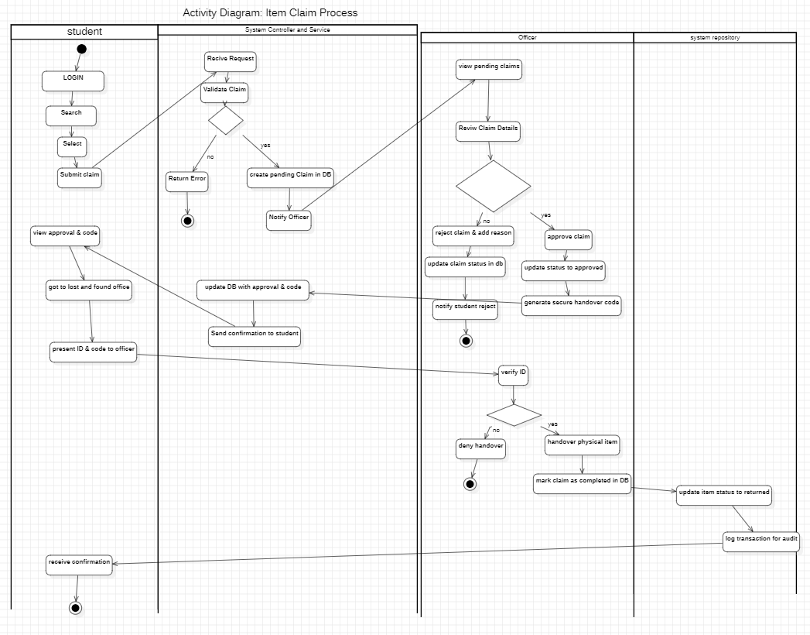

Model B: Sequence Diagram
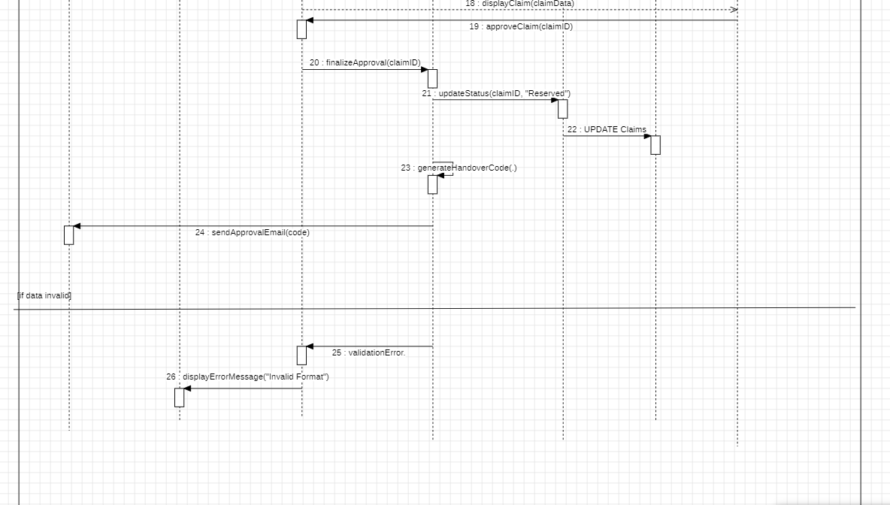
- Description: This diagram illustrates the time-ordered interaction between specific object lifelines representing our architectural layers. It demonstrates the MVC pattern in action, specifically showing how the Controller lifeline mediates communication between the View and Business Logic to maintain strict layering.
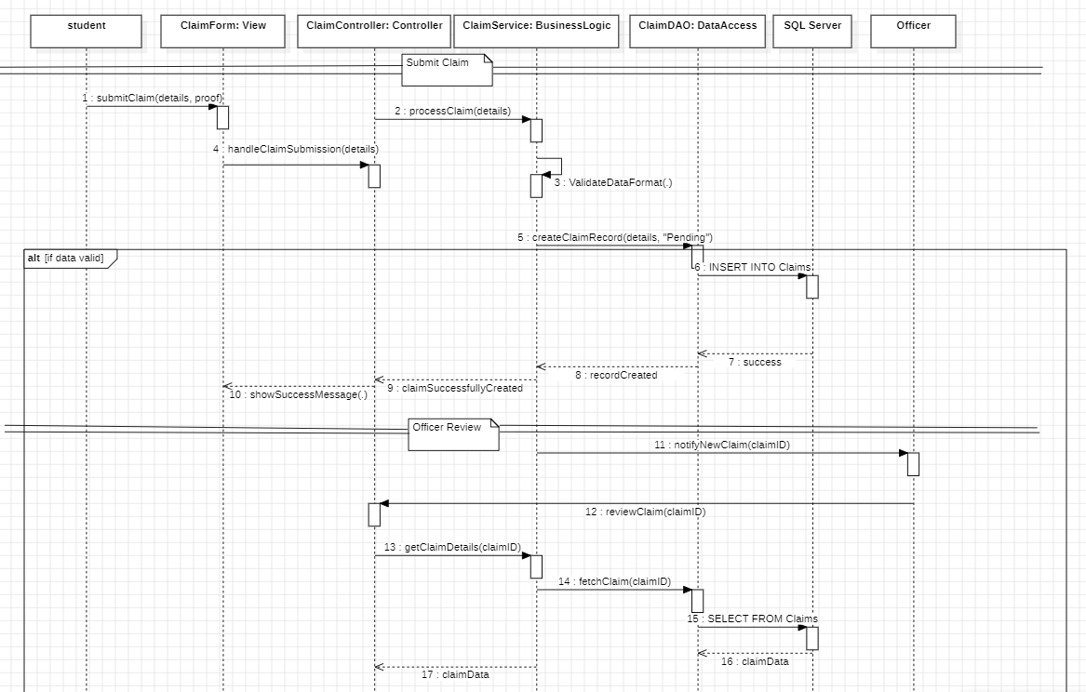
5. Development View (Component Diagram)
The Development View provides a static representation of the system’s decomposition into manageable software modules. This formal UML Component Diagram illustrates how the internal code is organized into subsystems, explicitly defining the dependencies required to implement the system's features.
The model identifies three core modules:
- User Interface Module: Encapsulates the Java Swing boundary classes responsible for presentation.
- Application Logic Module: Houses the controllers and core entities that enforce business rules.
- Data Management Module: Contains the Data Access Objects (DAOs) and persistence logic.
The directed dependencies (arrows) confirm that the system adheres to the architectural layers established in Phase 1, ensuring that high-level UI modules do not have direct dependencies on low-level data persistence.

6. Physical View (Deployment Diagram)
The Physical View maps the software artifacts to the physical hardware nodes where they are executed at runtime. This UML Deployment Diagram illustrates the distributed nature of the system, defining the communication paths between client-side devices and server-side processors.
The model identifies three primary physical nodes:
- Student Device (PC/Mobile): Hosts the local execution environment (JVM) required to run the Java Swing presentation artifacts.
- Application Server: A centralized node where the core business logic components and MVC controllers are deployed to manage system-wide transactions.
- Database Server: A dedicated persistence node hosting the SQL Server engine, ensuring isolated and secure management of all user and item records.
This view confirms the system's scalability, as the separation of the Application and Database servers allows for independent hardware optimization.

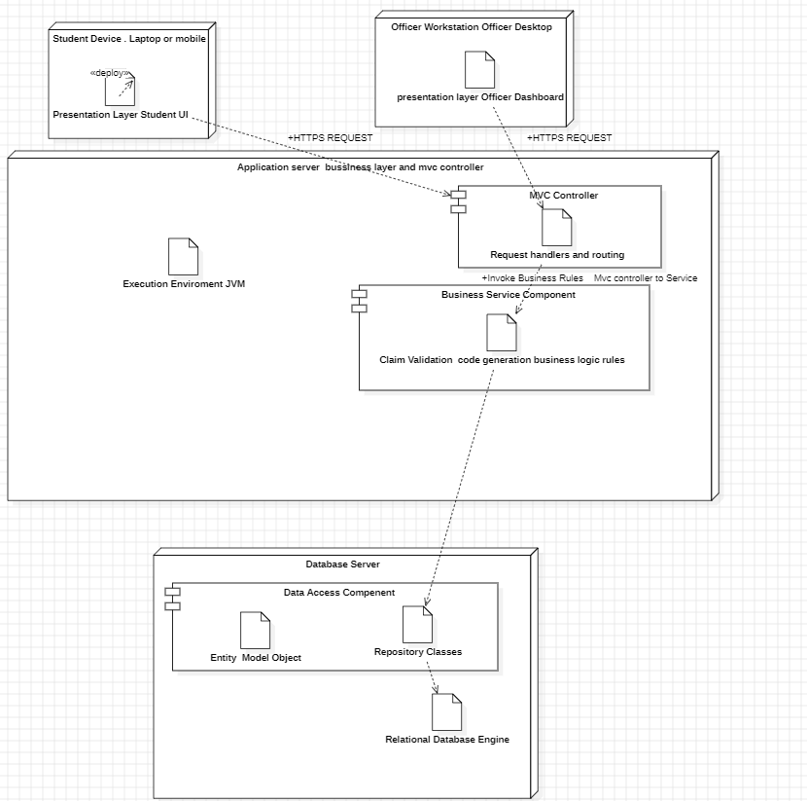

7. Bonus: Reference Architecture Identification
This section identifies the system’s alignment with established reference architectures to justify the design's robustness and industrial relevance.
7.1 Identification of Reference Architecture
Based on the comprehensive analysis of the system repository, the Lost and Found system fundamentally aligns with the Information System Reference Architecture. Specifically, it is implemented as a Three-Tier (Three-Layer) Desktop-Based Information System.
While the system shares characteristics with a Transaction Processing System (TPS)—as it processes discrete actions like "Registering an Item"—its primary architectural purpose is the storage, retrieval, and presentation of information through a structured graphical interface.
7.2 Technical Relevance & Justification
The adoption of this reference architecture is beneficial for several technical reasons:
- Separation of Concerns: Decoupling the Java Swing UI from the database logic allows for future frontend migrations (e.g., to Web or JavaFX) without altering core business rules.
- Design Pattern Integration: The architecture provides clear boundaries for professional patterns. This project utilizes the Strategy Pattern for search filters, Observer for system notifications, and Singleton for efficient database connection management.
- Scalability of Development: The layered structure allowed five team members to develop the UI, Logic, and DAO layers simultaneously without code conflicts.
7.3 Conclusion
The system serves as a textbook example of a layered Information System, successfully employing a Three-Tier architecture to manage the complexities of user interaction, business rule enforcement, and persistent data storage.

